Server Setup – Additional Configuration
Name: Juliette Joseph-Odogbo
Course: Linux Administration – Fall 2025
Date: October 16, 2025

1. Check and Add Repositories
This section was completed on October 16, 2025, and shows how to check the default repositories and add new ones on both Ubuntu and CentOS servers.

Ubuntu
Start by checking the default repositories on your Ubuntu server. These are the sources that apt uses to download and install software packages. The main list is stored in the file /etc/apt/sources.list. Use the following command:
cat /etc/apt/sources.list
Screenshot – Ubuntu: sources.list output
Next, check for any additional repositories stored in /etc/apt/sources.list.d/. This folder usually contains .list files added by PPAs or third-party sources.
ls /etc/apt/sources.list.d/
Screenshot – Ubuntu: list of additional sources
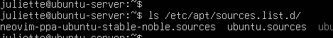
Ubuntu – Adding a Repository (PPA)
On Ubuntu, one of the most common ways to add extra software sources is by using a PPA (Personal Package Archive). This is useful when you want to install newer versions of software or tools not included in the default repositories.
The example below adds the Neovim PPA:
sudo add-apt-repository ppa:neovim-ppa/stable
When prompted, press Enter to continue. Ubuntu will automatically add the PPA and refresh the package list.
Screenshot – Ubuntu: Neovim PPA successfully added (the one you just shared)
After adding a PPA, run the update command to make sure your system recognizes the new source:
sudo apt update
Screenshot – Ubuntu: apt update after adding PPA

The first command adds the new repository, and the second refreshes the package list so Ubuntu knows about it.
Screenshot – Ubuntu: adding PPA and running apt update
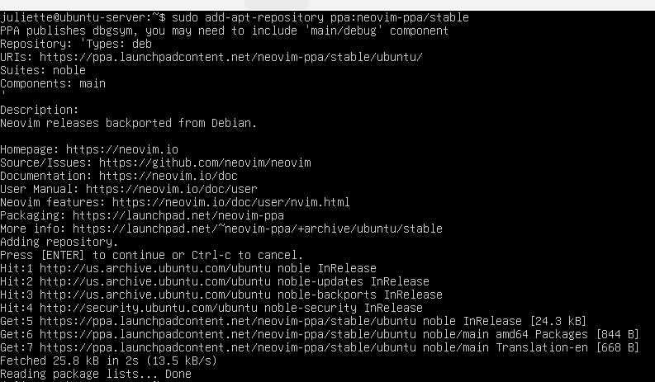
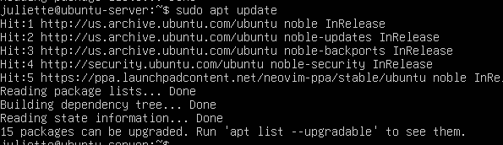
CentOS
On CentOS, repository information is stored in .repo files inside the /etc/yum.repos.d/ directory. However, the easiest way to view which repositories are currently enabled on the system is by using the dnf repolist command.
dnf repolist
This command displays the active repositories along with their IDs and names in a simple table format.
Screenshot – CentOS: dnf repolist output
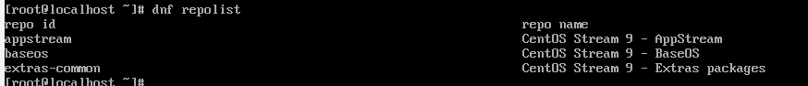
By default, CentOS comes with a few main repositories enabled, such as:
- AppStream – contains application packages and newer versions of software.
- BaseOS – provides the core packages needed for the system.
- Extras – contains additional useful packages not in the main repos.
If you ever want to add new repositories (for example, the EPEL repository), you can do this by creating or editing .repo files in /etc/yum.repos.d/ or by running:
sudo yum install epel-release -y
On some systems, this may require additional configuration before it works. For now, just listing and understanding the default repos is enough to continue with the setup.

CentOS – Adding a Repository (EPEL)
On CentOS, one of the most common ways to add a new repository is by installing the EPEL (Extra Packages for Enterprise Linux) repository. This gives you access to additional packages that are not included in the default repos.
sudo yum install epel-release -y
This command installs the EPEL .repo file into /etc/yum.repos.d/. After the installation finishes, update the system so CentOS can recognize the newly added repository:
sudo yum update -y
screenshot – CentOS: yum update after adding or attempting to add a repo

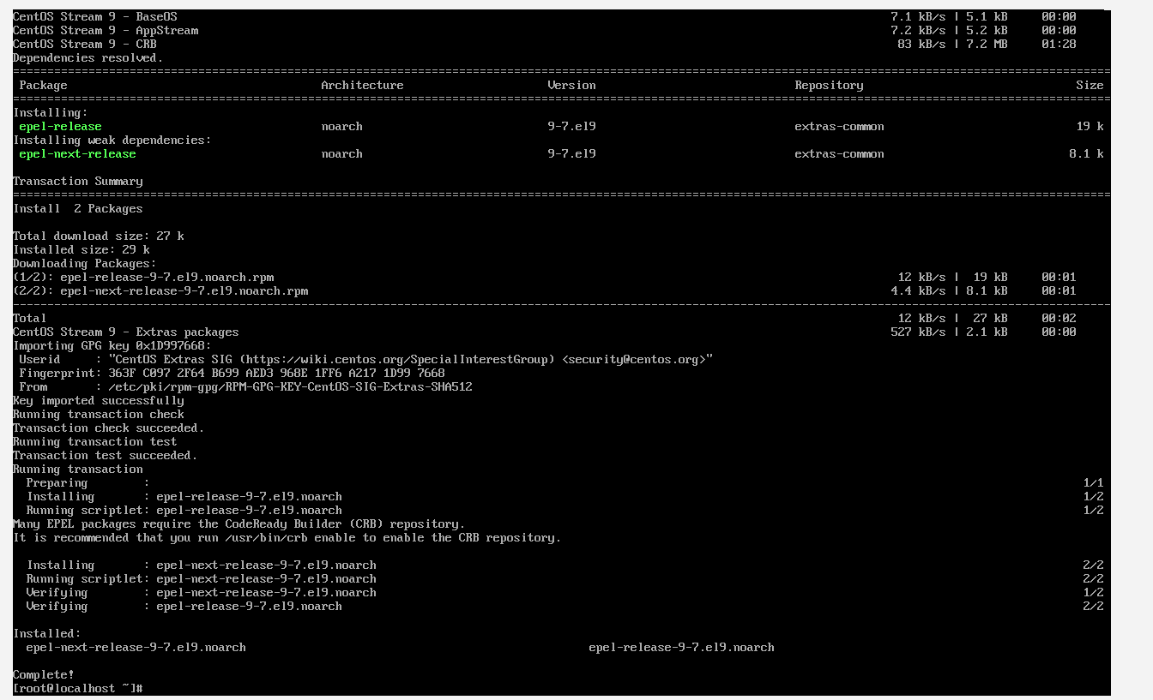
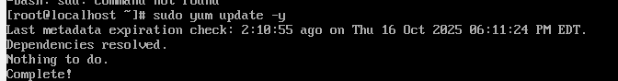

Whether you use the EPEL install command or manually create a .repo file, this step shows how to add additional software sources on CentOS. This mirrors the PPA step you performed on Ubuntu.
Next, run dnf makecache to rebuild the local metadata cache and confirm that the new EPEL repositories are active. You should see them appear in the output.
dnf makecache
Screenshot – CentOS: dnf makecache output showing EPEL repositories
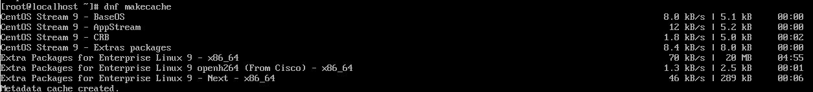
Server Name: ubuntu-server
Date Completed: October 16, 2025
This section shows how to install tmux, emacs, and fail2ban on the Ubuntu server (ubuntu-server), then configure Fail2ban to protect SSH. Each screenshot in this section is taken from the Ubuntu machine.
Part A: Ubuntu – Install tmux, emacs, and fail2ban
Start by installing tmux, emacs, and fail2ban on Ubuntu using the apt package manager. You can install them all at once with a single command:
sudo apt install tmux emacs fail2ban -y
The -y flag automatically answers “yes” to any prompts during installation
What happens:
- The terminal will turn green and white as apt begins downloading.
- You will see progress bars showing the download and installation stages.
- Once finished, it returns to your shell prompt without errors.

Screenshot – Ubuntu: installation output for tmux, emacs, fail2ban
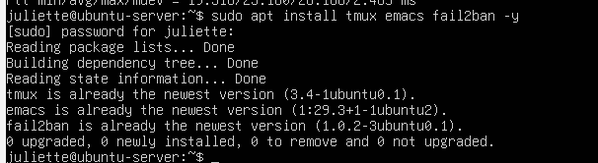
Once installed, check that each program is available by running their version commands:
tmux -V
emacs --version
sudo fail2ban-client --version
Screenshot – Ubuntu: version checks
What happens:
• Each command should print the version number.
• For example, tmux -V might display something like tmux 3.2a.
• If a command is not found, the installation failed.

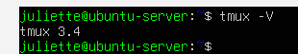
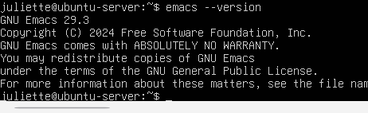

Step 3: Default Fail2ban Configuration
File: /etc/fail2ban/jail.conf
To view the default Fail2ban configuration, run:
cat /etc/fail2ban/jail.conf
Why:
- This displays the entire configuration file in the terminal.
- You can review default service sections (like [sshd]) and log paths before creating your custom jail.local file.
Screenshot — Default jail.conf output
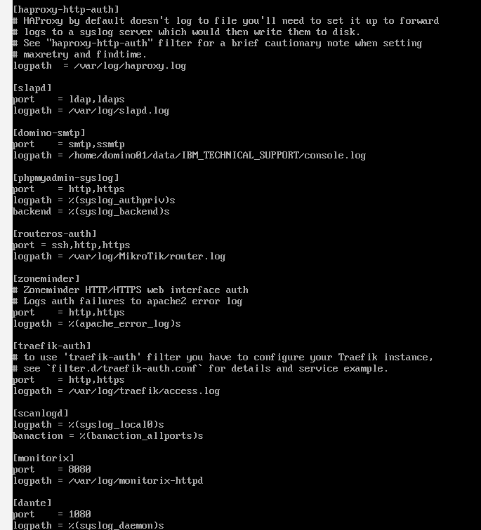

Note:
You should not edit jail.conf directly. Instead, use it to view the default settings, then create a separate jail.local file to make changes. This ensures that updates to Fail2ban do not overwrite your custom configuration.

Step 4: Local Fail2ban Configuration (Changes Made)
File: /etc/fail2ban/jail.local
sudo nano /etc/fail2ban/jail.local
Add:
[sshd]
enabled = true
bantime = 600
What changed:
- enabled: false → true
- Added bantime (10 min ban).
Why: enable SSH protection and temporarily block repeated failed logins.
Screenshot – Ubuntu (ubuntu-server): jail.local in Nano
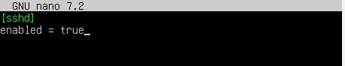
Troubleshooting and Verifying Fail2ban (Ubuntu)
Check the service status
sudo systemctl status fail2ban
If you see inactive (dead) or failed, the service is not running.
Start the Fail2ban service
sudo systemctl start fail2ban
This will create the socket file (/var/run/fail2ban/fail2ban.sock) and start monitoring according to your jail.local configuration.
Enable Fail2ban at startup (in case you did not yet)
sudo systemctl enable fail2ban
Re-run the SSH jail status command
sudo fail2ban-client status sshd
This time, if the service started correctly and your SSH jail is configured, you should see:
- The jail name sshd appears in green
- You will also see:
  - Currently banned: 0
  - Total banned: 0
  - Banned IP list:

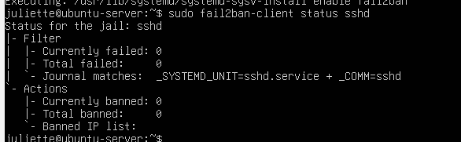

Section 3: Program Locations, Opening, Using, and Closing – Ubuntu Server
Server Name: ubuntu-server
Date Completed: October 17, 2025
This section shows where each installed program is located on the system, how to open it, what to expect visually, basic usage, and how to close it. This helps anyone else replicate these steps confidently on their own Ubuntu server.

1. Tmux
Location
Check where tmux is installed:
Command: which tmux
Expected output:
/usr/bin/tmux
Screenshot – Ubuntu (ubuntu-server): tmux location
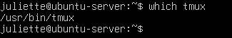
Open
Command: Tmux
What happens:
- The terminal refreshes.
- A green status bar appears at the bottom of the screen.
- The rest of the terminal becomes blank, ready for commands inside tmux.
Screenshot – Ubuntu (ubuntu-server): tmux opened with green bar
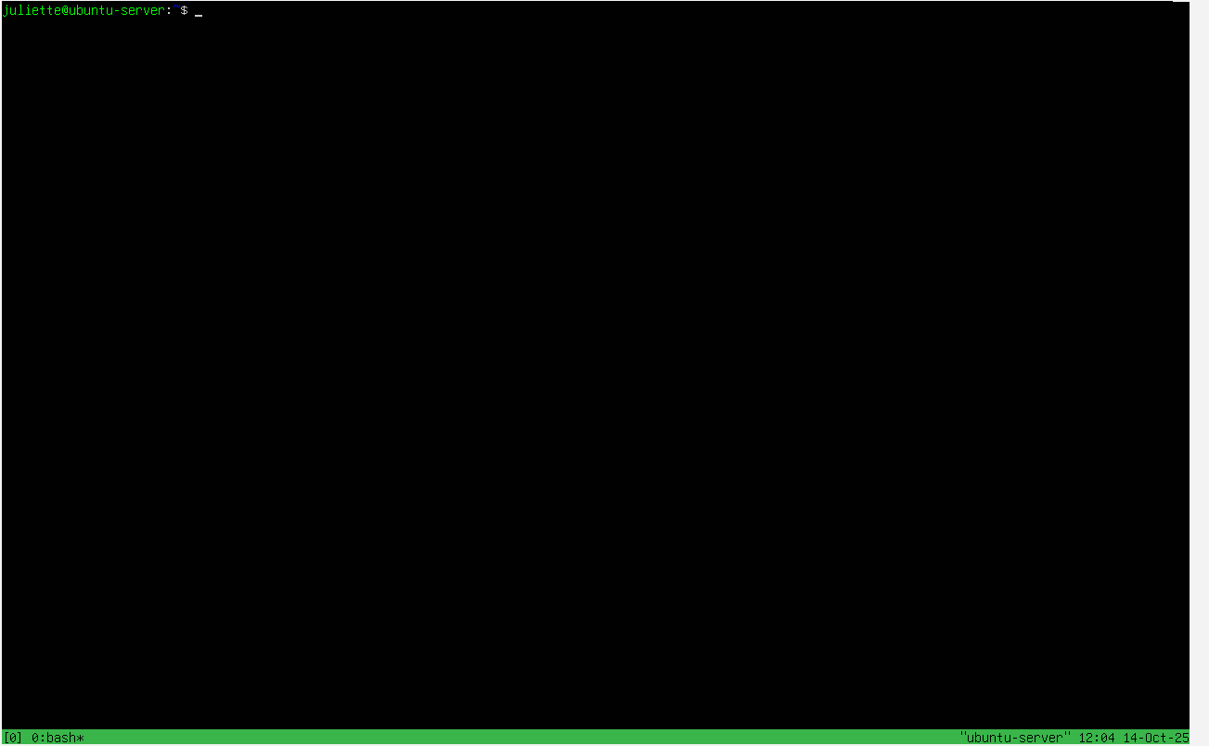
Basic Use
To detach from tmux without closing it:
Ctrl + B then D
This takes you back to the normal terminal prompt, leaving tmux running in the background.

Close
Inside tmux, type:
exit
The green bar disappears and you return to the normal shell prompt.
Screenshot – Ubuntu (ubuntu-server): tmux session closed
Emacs
Location
To find where Emacs is installed on the system, use the which command:
which emacs
This command tells you the full path of the executable file for Emacs.
On a standard Ubuntu install, the expected output is:
/usr/bin/emacs
This confirms that Emacs is installed and available system-wide.
Screenshot – Ubuntu (ubuntu-server): emacs location
Open
Command: emacs
What happens
- Emacs takes over the terminal and opens in full-screen mode.
- The screen turns blue/purple, with a menu bar at the top, a welcome/help screen in the middle, and a status bar at the bottom.
- This layout is normal — Emacs has its own interface, not just a text prompt.
- You can use the arrow keys to move around and the status bar will update.
What to expect:
If you see this interface, Emacs is installed correctly. If you get command not found, it was not installed. If nothing changes visually, the terminal might not support full-screen mode.
Screenshot – Ubuntu (ubuntu-server): Emacs welcome screen
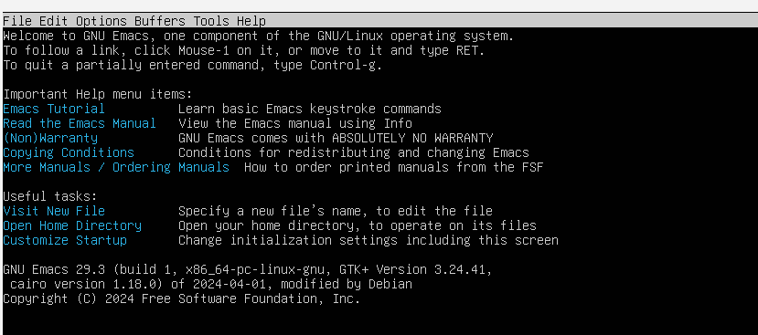

Close
Press:
Ctrl + X then Ctrl + C
This is the proper way to exit — Emacs will not close with exit like a shell.
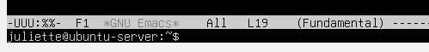
. fail2ban
Location
To find where Fail2ban is installed, run:
which fail2ban-client
Expected output:
/usr/bin/fail2ban-client
This confirms the Fail2ban client tool is installed system-wide.
Screenshot – Ubuntu (ubuntu-server): fail2ban location
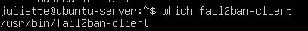

Open / Check
There is no GUI to “open.” You interact with Fail2ban by checking its status:
sudo fail2ban-client status
sudo fail2ban-client status sshd

How to Use
- sudo fail2ban-client status shows all active jails.
- sudo fail2ban-client status sshd checks the SSH jail specifically.
- When the service is working, you will see:
  - sshd in green (means the jail is active)
  - Currently banned: 0 (normal on a new setup)
  - Total banned: count and an empty banned IP list if no attacks yet.
What to expect:
- If you see an error like Failed to access socket path, the service is not running → use:
- sudo systemctl start fail2ban
- If sshd does not show up at all, check your jail configuration file for typos or make sure the jail is enabled.
Screenshot – Ubuntu (ubuntu-server): sshd jail status in green
Close
There is no separate interface to close. Once the output appears, just press Enter or Ctrl + C to return to the shell prompt.
Cowsay
Server: ubuntu-server
Date Completed: October 17, 2025
installation
To install cowsay on Ubuntu, run:
sudo apt install cowsay -y
This installs the package and makes it available system-wide.
Screenshot – Ubuntu (ubuntu-server): cowsay installation
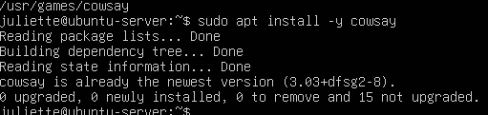

Location
Check where cowsay is installed:
Command: which cowsay
Expected output:
/usr/games/cowsay
This confirms that cowsay is installed and available system-wide.
Screenshot – Ubuntu (ubuntu-server): cowsay location
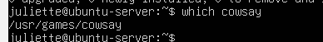
Open / Use
Cowsay does not have a GUI. You use it by typing a phrase after the command:
cowsay "Hello from Ubuntu!"

How to Use
- Cowsay takes your text and prints it as if a cow is “saying” it in ASCII art.
- When you run the command, a little cow pops up in the terminal with your message inside a speech bubble, like it is talking to you.
- You can replace the text inside the quotes with anything you want.
What to expect:
- If cowsay is installed correctly, you will see the cow ASCII art right away.
- If you get command not found, cowsay was not installed. Reinstall with:
- sudo apt install cowsay -y
Screenshot – Ubuntu (ubuntu-server): cowsay output with “Hello from Ubuntu!”
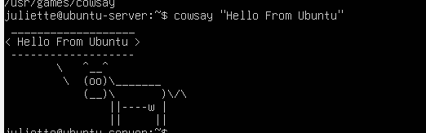
Close
No special close needed — once the ASCII cow displays, you are back at the prompt automatically.
Lolcat:
Server: ubuntu-server
Date Completed: October 17, 2025
installation
To install lolcat on Ubuntu, run:
Command: Sudo apt install lolcat -y
This installs lolcat and makes it available for use directly in the terminal.
Screenshot – Ubuntu (ubuntu-server): lolcat installation
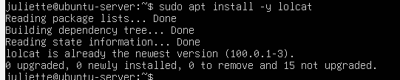
Location
Check where lolcat is installed:
which lolcat
Expected output:
/usr/games/lolcat
This confirms that lolcat was installed successfully.
Screenshot – Ubuntu (ubuntu-server): lolcat location
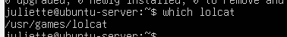
Open / Use
Lolcat works by coloring text. You can use it by piping any text into it. For example:
echo "Hello from Ubuntu" | lolcat

How to Use
- When you run the command, the text you typed is printed back on the screen in rainbow colors, line by line.
- It does not open a new program — it just takes whatever text you give it and makes it colorful.
- You can use it with echo like above, or pipe output from any other command.
What to expect:
- If lolcat is installed correctly, the text should appear in multiple colors right away.
- If you get command not found, the installation did not work — run the install command again.
Screenshot – Ubuntu (ubuntu-server): lolcat rainbow text output
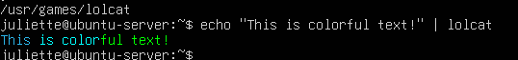
Close
No special close needed — once the colored text is printed, the terminal returns to the prompt.
Vim (Update VI to Vim)
Server: ubuntu-server
Date Completed: October 17, 2025
installation / Update
Install Vim so that it replaces the basic vi editor:
sudo apt install vim -y
This ensures the system has the full Vim editor.
Screenshot – Ubuntu (ubuntu-server): vim installation
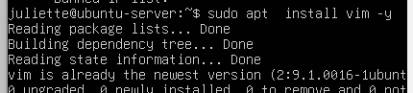
Set vi to use Vim by default
On some systems, vi still points to a minimal editor. You can update the system’s default editor so that vi uses Vim:
sudo update-alternatives --config editor
This brings up a list of installed editors.
- Type the number that corresponds to Vim (usually 2 or 3), then press Enter.
- After this, running vi will open Vim.
Screenshot – Ubuntu (ubuntu-server): selecting Vim as default editor
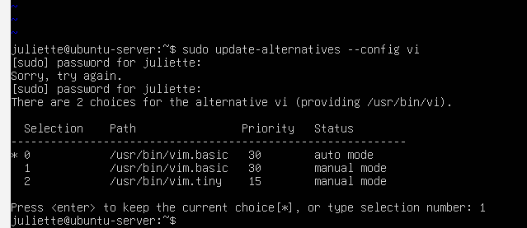
Location
Check where Vim is installed:
which vim
Expected output:
/usr/bin/vim
This confirms Vim is installed and set.
Screenshot – Ubuntu (ubuntu-server): vim location
Open
Command: vim

How to Use
- When you open Vim, a blue welcome screen appears with version info at the top and helpful tips in the middle.
- It starts in Normal mode, so typing does not insert text yet.
- Press i to switch to Insert mode — you will see -- INSERT -- at the bottom. You can now type normally.
- Press Esc to go back to Normal mode.
What to expect:
If everything worked, vi and vim should both open this same welcome screen now.
Screenshot – Ubuntu (ubuntu-server): Vim welcome screen
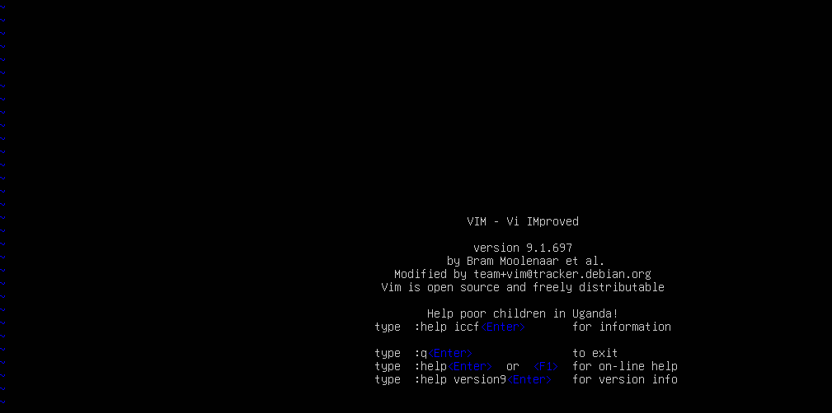
Close
- Quit without saving:
- :q
- Save and quit:
- :wq
Server: centos-server
Date Completed: October 17, 2025
This section shows how to install tmux, emacs, and fail2ban on the CentOS server (centos-server), then configure Fail2ban to protect SSH. Each screenshot in this section is taken from the CentOS machine.
Part A: CentOS – Install tmux, emacs, and fail2ban
- On CentOS, we use yum (or dnf on newer systems) to install software. It is the built-in package manager that pulls from official repositories, installs dependencies automatically, and keeps the system secure and organized.

To install Tmux, Emacs, and Fail2ban together, run:
sudo yum install tmux emacs fail2ban -y
The -y flag automatically agrees to prompts.
Screenshot – CentOS (centos-server): yum installation of tmux, emacs, fail2ban
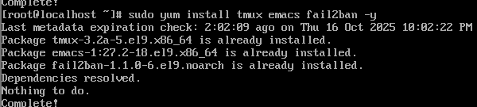

Part B: CentOS – Check Versions / Locations
Once the installation is complete, it is important to confirm that all three programs were installed successfully and are in the expected locations.
Run the following commands:
which tmux
which emacs
which fail2ban-client
These commands show the file path for each program. If the program is installed correctly, it should return a path inside /usr/bin/.
Expected output:
/usr/bin/tmux
/usr/bin/emacs
/usr/bin/fail2ban-client
Screenshot – CentOS (centos-server): tmux, emacs, fail2ban locations
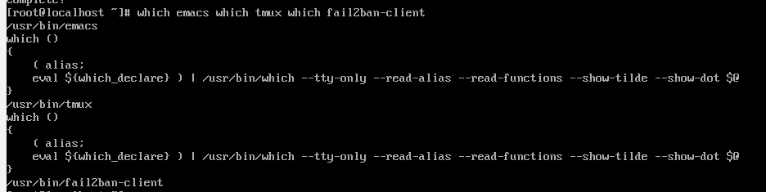
What to expect:
- Seeing all three paths confirms that the installation worked.
- If any command returns “not found,” rerun the install command to fix it.
Part C: CentOS – Fail2ban Configuration
When installing Fail2ban, it is important to check the default settings first and then note any changes needed to make it work correctly. This ensures SSH protection is set up the right way.
Step 1: Review Default Settings
Fail2ban’s default configuration is stored in:
/etc/fail2ban/jail.conf
Open the file to look at the default SSH jail:
sudo less /etc/fail2ban/jail.conf
By default, the [sshd] jail is present and enabled
Screenshot – CentOS (centos-server): jail.conf default sshd section
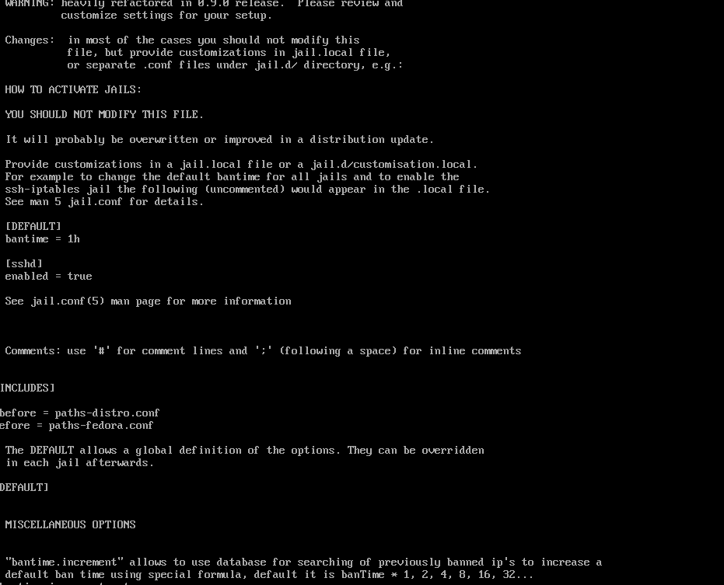
We do not edit this file directly because updates can overwrite it. Instead, we make changes
[sshd]
Enabled = true
What this means:
SSH protection is already enabled by default. However, the top of the file clearly warns:
“You should not modify this file. It will probably be overwritten or improved in a distribution update. Provide customizations in a jail.local file…”
So, even though SSH is enabled here, the recommended practice is to create a separate jail.local file to make your configuration persistent and custom
Step 2: Create jail.local (Modification)
Create the file:
sudo vim /etc/fail2ban/jail.local
Add:
[sshd]
enabled = true
port = ssh
filter = sshd
logpath = /var/log/secure
maxretry = 5
Screenshot – CentOS (centos-server): jail.local configuration
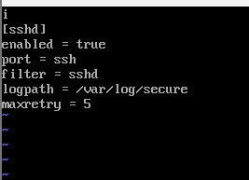
Why this modification is needed:
- jail.conf can be overwritten by updates, so jail.local preserves our configuration.
- We also set CentOS-specific logpath (/var/log/secure) and added a maxretry policy.
- This ensures SSH protection stays active even after system update

Step 3: Start and Enable the Service
sudo systemctl start fail2ban
sudo systemctl enable fail2ban
Screenshot – CentOS (centos-server): start and enable fail2ban
Step 4: Check Jail Status
sudo fail2ban-client status sshd
What to expect:
- sshd should appear in green.
- Currently banned: 0 on a fresh setup.
- This confirms Fail2ban is actively monitoring SSH.
Screenshot – CentOS (centos-server): sshd jail status
If you see an error about the socket, the service likely was not started — just rerun the start command.
On CentOS, the SSH jail status does not always show sshd in green like Ubuntu. Instead, you should look for the Status for the jail: sshd section with the filter and action details to confirm the jail is active. Seeing these values confirms that Fail2ban is working.”
Server: centos-server
Date Completed: October 17, 2025
Part D: Using Tmux and Emacs
1. Tmux
Open Tmux
Command: tmux
Screenshot – CentOS (centos-server): tmux opened
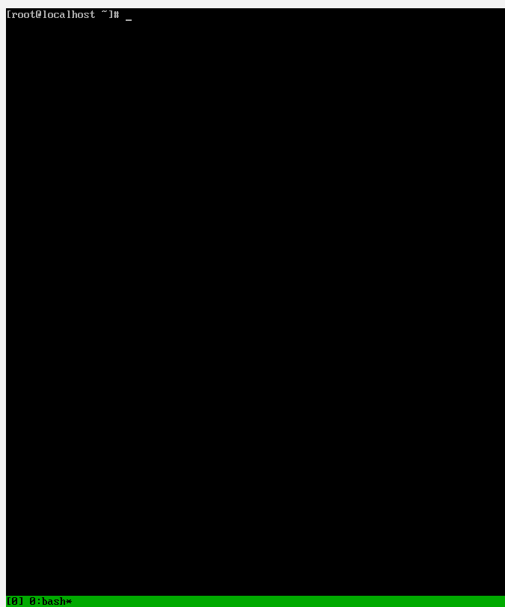
How to Use
- When you open Tmux, the screen refreshes and a green status bar appears at the bottom.
- This tells you are inside a Tmux session.
- To detach and return to the normal terminal:
- Ctrl + B, then D
- To reconnect:
- tmux attach
What to expect:
The green bar confirms Tmux is running.
Close Tmux
Type exit on the command prompt

2. Emacs
Open Emacs
emacs
Screenshot – CentOS (centos-server): Emacs welcome screen
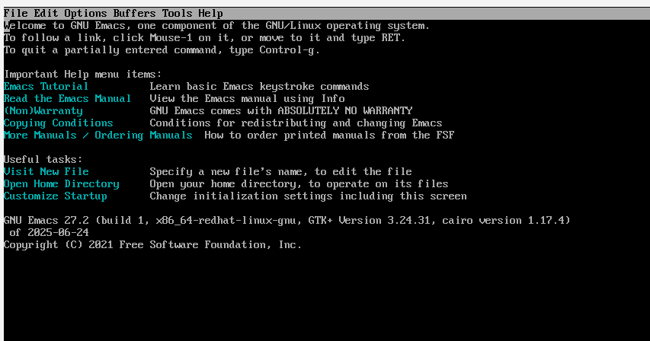
How to Use
- Emacs opens in full-screen mode with a blue/purple background, a menu bar at the top, and a welcome/help screen in the middle.
- Use the arrow keys to move.
- For help:
Ctrl + H
What to expect:
Seeing the Emacs welcome screen confirms it is installed and working.
Close Emacs
Ctrl + X, then Ctrl + C
- This exits Emacs and returns you to the terminal.
server: centos-server
Date Completed: October 17, 2025
Cowsay
Installation
To install cowsay on CentOS, run:
sudo yum install cowsay -y
This installs the package and makes it available system-wide.
Screenshot – CentOS (centos-server): cowsay installation
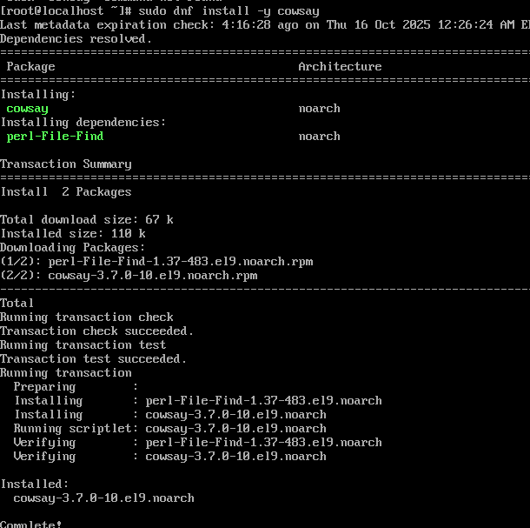
Location
Check where cowsay is installed:
Command:
which cowsay
Expected output:
/usr/bin/cowsay
Screenshot – CentOS (centos-server): cowsay location
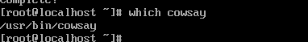
How to Use
To test cowsay, run:
cowsay "Hello from CentOS!"
This displays the message inside a speech bubble above the ASCII cow.
Screenshot – CentOS (centos-server): cowsay output
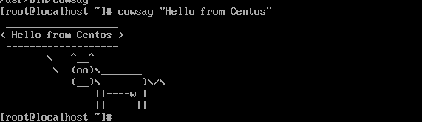
What to Expect
- The message appears inside a bubble with the cow below it.
- This confirms cowsay is installed and working correctly.

How to Close
There is no special close needed. Once the cow displays your message, the program ends automatically and you return to the terminal prompt.

Server: centos-server
Date Completed: October 17, 2025
Lolcat
Step 1: Try Installing Lolcat (Fails)
Command:
sudo dnf install -y lolcat
Why:
Always try the direct install first. If this fails, it tells you that the package is not available in any currently configured repository.
Expected Result:
You will see an error like:
Error: Unable to find a match: lolcat
Screenshot 1 — Lolcat Install Attempt (Failed)

Step 2: Install Ruby
Lolcat is distributed as a Ruby gem, so you must install Ruby first to access the gem package manager.
Command:
sudo dnf install -y ruby
Why:
This installs Ruby and its package manager so that you can fetch Lolcat directly from the Ruby Gems repository.
Expected Result:
- The system downloads and installs Ruby packages.
- The terminal returns to the prompt with no errors.
Screenshot 2 — Install Ruby
Label: CentOS — Ruby Installed
Step 3: Verify Ruby Installation
Command:
ruby --version
Why:
Checks if Ruby is working correctly before using it to install Lolcat.
Expected Result:
Something like:
ruby 3.x.x (2025-xx-xx revision ...)
Screenshot 3 — Ruby Version
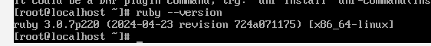
Step 4: Install Lolcat Using Gem
Command:
sudo gem install lolcat
Why:
This fetches Lolcat directly from the Ruby Gems repository, which is the correct way to install it on CentOS when it is not in the standard repos.
Expected Result:
- Several lines showing the gem being downloaded and installed.
- At the end, you should see:
Successfully installed lolcat-xxx
Screenshot 4 — Lolcat Gem Installation
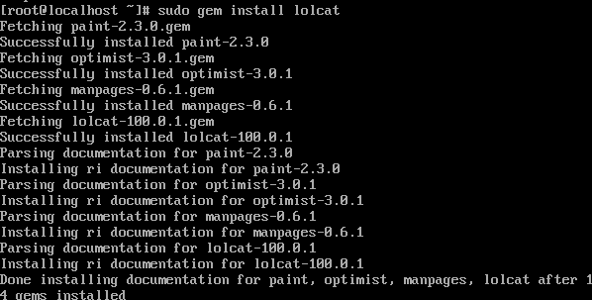
Step 5: Location
After installing via Ruby Gems, check where lolcat is stored:
Command:
which lolcat
Expected Result:
It typically shows something like:
/usr/local/bin/lolcat
This is Ruby’s gem binary path on CentOS, not the regular /usr/bin.
Screenshot 5 — Lolcat Location
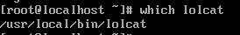

Step 5: How to Use
Once installed, test Lolcat with:
echo "Hello from CentOS" | lolcat
- echo prints the message.
- The pipe (|) sends the output to lolcat.
- Lolcat displays it in rainbow colors

Screenshot 5 — Lolcat Rainbow Output
Label: CentOS — Lolcat Working

Step 6: What to Expect
- The text prints in rainbow colors.
- No extra configuration is needed after the gem install.
- You return to the terminal prompt automatically.

Step 7: How to Close
Lolcat does not require a special close command. Once the text prints, the program exits automatically and you return to the terminal prompt.
Server: centos-server
Date Completed: October 17, 2025
Update vi to Vim
Step 1: Install Vim
By default, CentOS includes a minimal version of vi with limited features. To replace it with the full version of Vim, run:
sudo yum install -y vim
Why:
This installs the enhanced Vim editor with more functionality than the basic vi.
Expected Result:
The system downloads and installs Vim successfully, and you return to the terminal prompt.
Screenshot 1 — Vim Installation
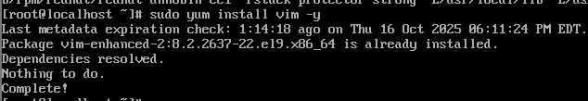
Step 2: Make Vim the Default Editor
After installation, set Vim as the default system editor using the alternatives system.
Commands:
sudo alternatives --install /usr/bin/editor editor /usr/bin/vim 100
sudo alternatives --config editor
Why:
- The first command registers Vim as a valid editor choice.
- The second command lets you pick Vim as the default editor through a menu.
Expected Result:
A menu like this appears:
There are 2 programs which provide 'editor'.

Selection Command
-----------------------------------------------
* 1 /usr/bin/nano
2 /usr/bin/vim
Enter to keep the current selection[+], or type selection number: 2
Type 1 and press Enter to select Vim as the default.
Screenshot 2 — Alternatives Menu for Default Editor
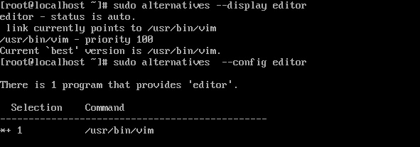
You can re-run sudo alternatives --config editor at any time to switch back to another editor.
Step 3: Test
To confirm that vi now opens Vim, run:
vi
Expected Result:
Vim launches with its welcome screen and version information at the bottom, instead of the minimal vi editor.
Screenshot 3 — Vim Opened via vi Command
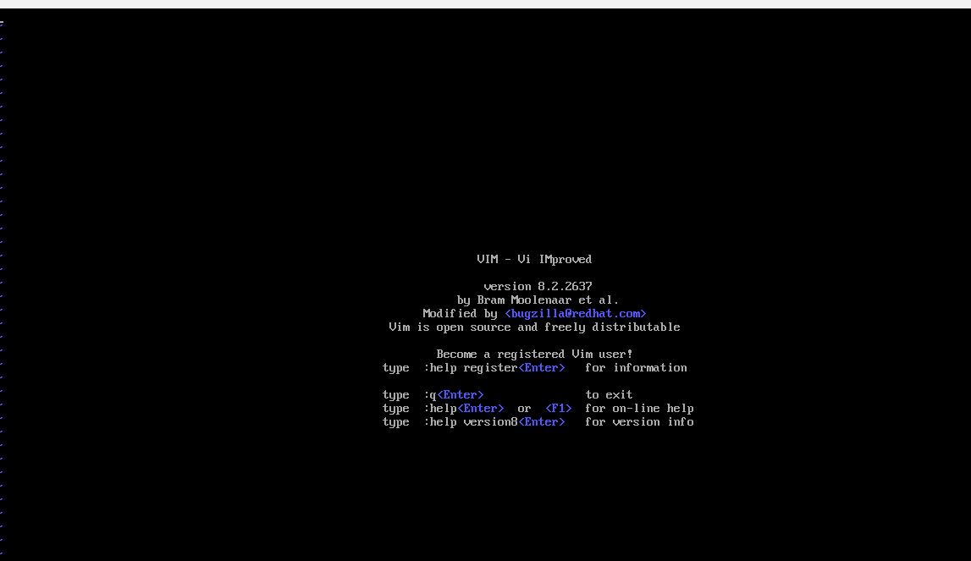
Step 4: How to Close Vim
To exit Vim:
- Press Esc
- Type:
- :q
and press Enter
If you made changes and want to exit without saving:
:q!
This closes Vim and returns you to the terminal prompt.

